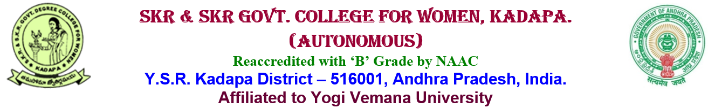___________________________________________________________________________
5.1.3: Following Capacity development and skills enhancement activities are organised for improving students capability 1. Soft skills 2. Language and communication skills 3. Life skills (Yoga, physical fitness, health and hygiene) 4. Awareness of trends in technology
CAPACITY ENHANCEMENT AND DEVELOPMENT SCHEME
Career Guidance & Counselling Cell (JKC)
Establishment:
It is a great privilege to present a report of our Jawahar Knowledge Centre in SKR & SKR Govt. College for Women, Kadapa (Autonomous) JKC was started in our college on 25th of April 2007 (summer batch with 86 students they were trained in three groups since the strength was more).This came out to be a grand success.
The Government of Andhra Pradesh with great foresight introduced need-based courses in the year 1998. Then a variety of restructured courses and combinations were started in this college. Ever since the staff of this college have been working to make the institution truly a center of learning and excellence that could deliver a goods in the competitive world of educational enterprise.
The staff and students of this college thank the Commissioner of Collegiate Education (CCE), A.P., who encouraged and supported us to face the tough tests offered by the evaluating body. They also thank all others including donors to various causes in the college and the elite of the Kadapa District, who have been encouraging them in this endeavour.
Functioning:

- JKC imparts training, in English language proficiency, Analytical skills, General Awareness, Communication Skills and Soft Skills.
- Our College conducts training programme 3 Batches in a year
- For JKC Training Programme as per CCE Instructions fixed fee of Rs.500 from BC & OC students and whereas No Fee is Collecting for the SC & ST Students.
- We are Providing JKC Study Material for Communication Skill and Soft Skills, Analytical skills & Computer Skills
- Our JKC is issuing ID Cards to the JKC Students
___________________________________________________________________________
CAPACITY ENHANCEMENT AND DEVELOPMENT SCHEME
Soft Skills
A soft skill is a personal attribute that supports situational awareness and enhances an individual's ability to get a job done. Soft skills were barely given importance over hard and tangible skills in earlier days. These skills that improves and develops the student behaviour and personality. The most key skills are innovativeness, social skills, critical thinking and interpersonal communication. The important reason why soft skills are introduced in any organisation is that they improve interpersonal skills among students. Interpersonal skills mean the ability to communicate and interact with other employees in the organisation.
This institution train students in the foundation courses, which includes English, ICT, Analytical and Soft Skills. These courses are an integral part of our curriculum as they make our students job-ready and one step closer to entering the industry. Our trainers give importance to soft skills and personality development training so that ready for job-interviews before they complete their course.
Curriculum for Soft skill Training
S.No | Component | No. of Hours
1 | Communication skills | 60
2 | Soft Skills | 30 soft skills,  10 Ethical Values
3 | Analytical Skills | 60
4 | Technical skills | 60
5 | General Awareness | 30
 | Total | 250

___________________________________________________________________________
CAPACITY ENHANCEMENT AND DEVELOPMENT SCHEME
English Language Lab
Language Lab software is a classroom based solution which will be installed on the computer in classroom and the content can be accessible in the respective classroom system. English Language becomes the default option for communication as it is spoken and understood across the global. While proficient English-speaking skills appeals your resume and it can boost hiring potential. A recent survey by LinkedIn stated that CEOs and HR Directors prefer English speaking employees over other languages.
English Language is not the first language for many Indians and it is a language ought to be learned. It is only taught in few English medium schools across the country; hence, a huge chunk of population never got the opportunity to learn English language.

___________________________________________________________________________
CAPACITY ENHANCEMENT AND DEVELOPMENT SCHEME
Yoga and Meditation

Practicing Yoga is known to improve flexibility, balance, endurance and physical strength while Meditation helps to keep the mind sharp, relieves stress and improves overall well being. This institution promotes health benefits among the students through Yoga and Meditation. This wellness platform hugely contributes in creating stressfree positive environment and healthy way of thinking and living. Every year conducts many programs related to Yoga and Meditation. College celebrates International Yoga day since its inception. Techniques of Meditation and various postures like Asana are performed to lead a healthy and stress free life. Department of physical education regularly conducts yoga classes for the students.

___________________________________________________________________________
CAPACITY ENHANCEMENT AND DEVELOPMENT SCHEME
Bridge course and Remedial Coaching
Bridge Course:
A bridge course for newly admitted students is conducted every year before the commencement of the first semester regular classes. The main objective of the course is to bridge the gap between subjects studied at Pre-university level and subjects they would be studying in Graduation. The syllabus for the course is framed in such a way that they get basic knowledge on the subjects which they would be learning through graduation.
Objectiveness
Give students the confidence and skills to successfully transition to college and new curriculum.
Methodology
During the first week after the commencement of the classes, the bridge course curriculum is delivered to the students in various disciplines. A post bridge course test is conducted after the completion of bridge course syllabus to assess the ability of student’s suggestions are given to students for improvisation.
Remedial Classes:
Remedial classes are conducted for Average and slow learning students to assist them to achieve expected competencies in core academic skills such as literacy and numeracy. Selecting the students for remedial class- based on the previous semester end exam(SEE) marks/ Continuous Internal Assessment (CIA) marks, slow learners are identified, the students who find difficulty in grasping the courses are voluntarily enrolled.
Objectiveness
To develop academic skills and assist the students in various subjects.
To raise the level of understanding of students in basic subjects to improve themselves for further academic work.

Methodology

Remedial classes are organized on working days after regular class hours. A Special focus is laid to equip the students to help them perform well in the exams.An attendance sheet is maintained by the faculty members, which includes the student attendance and topics covered in the class and the reports maintained by all the Departments.

SOFT SKILLS

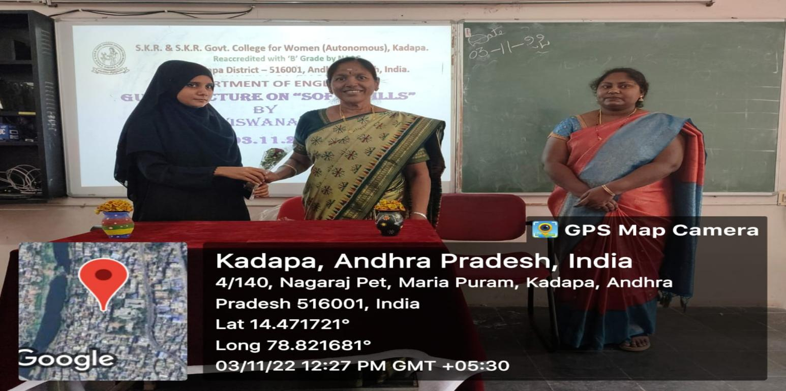

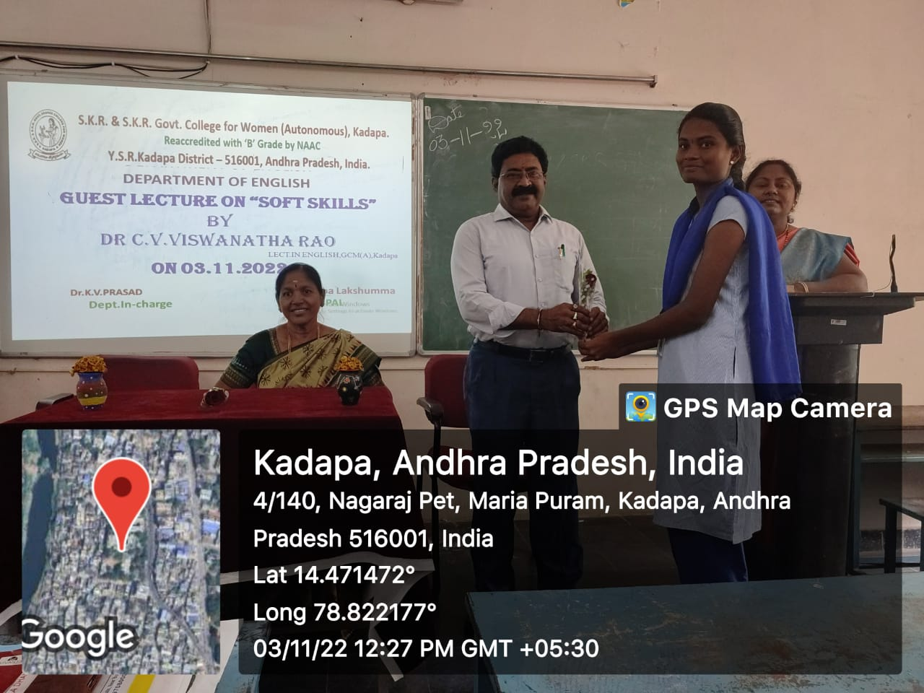

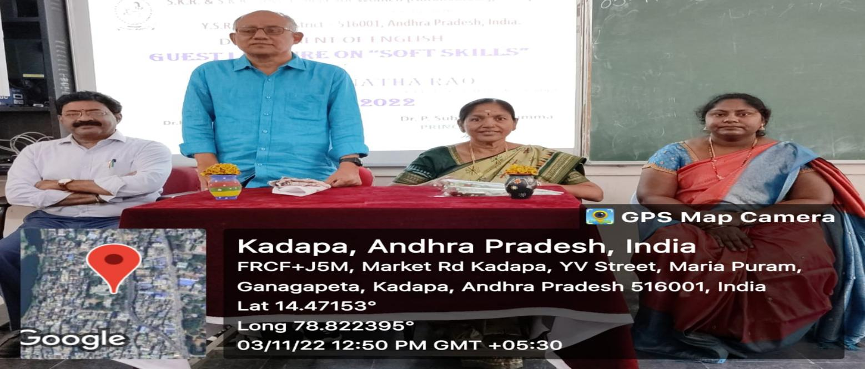

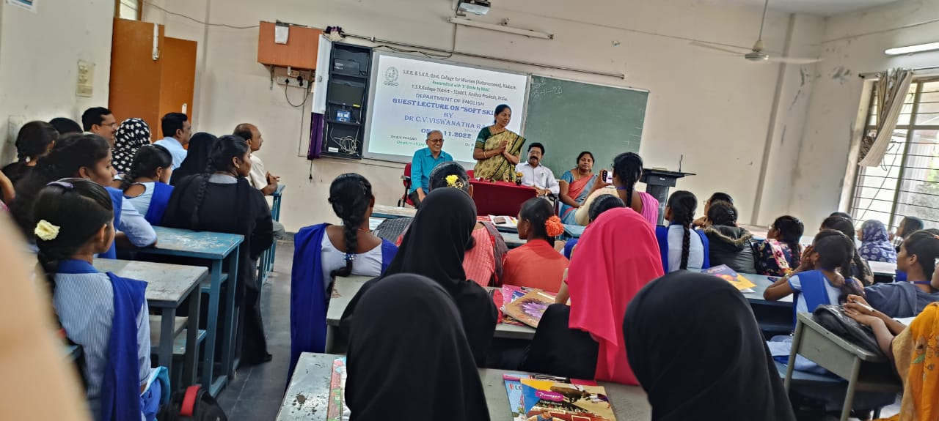

LANGUAGE AND COMMUNICATION SKILLS
To enlighten the students about the need and significance of English language and communication skills, so that they can choose right path in order to have a bright future.
Dr. P.Subbalakshumma, Princial of SKR & SKR Govt. Degree College for women (A), Kadapa has chaired the session and enlightened the students on the significance of English language and the required skills in order to reach a suitable position in this cut throat competitive world. And also motivated the students so that they can face the audience with great confidence.
Sri. B. Kesava Reddy, Lecturer in English has focused on language acquisition and the significance of the English language in the present day society. He also concentrated the need of language in order to get fluency in language and how to face interviews confidently. He has emphasised on the fluency rather than the accuracy in English. And also he stressed on how to make use of the present day technology to learn English language.
The programme enabled the students to come to know the significance of English language and also made them know how to acquire language by focusing on communication skills. Dr. K.V. Prasad , Head of the department motivated students to have a bright future. Mrs. P.Sujatha, Lecturer in English also took part in it and gave an inspiring speech. Mrs. G.P.Ashalatha, Lecturer in English spoke on this occasion and inspired the students. Dr. R.Rajanarayana, Lecturer in English also emphasised the importance of English language. Mr. A.Azmathulla, Lecturer in English proposed vote of thanks on this occasion.

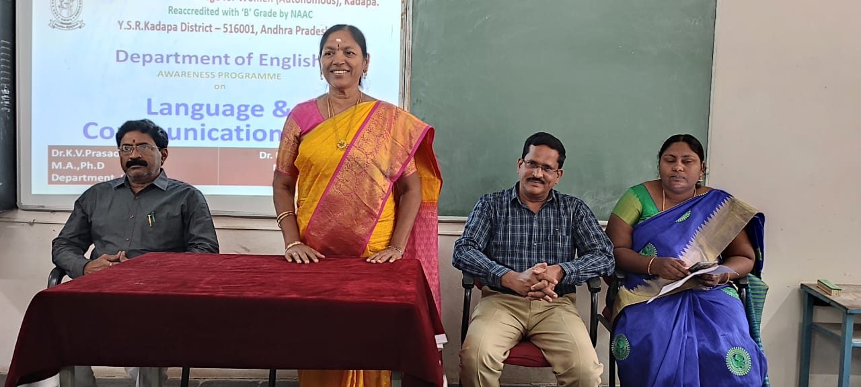
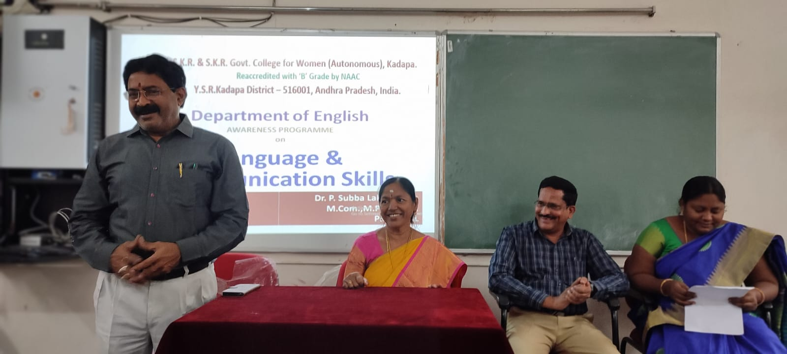

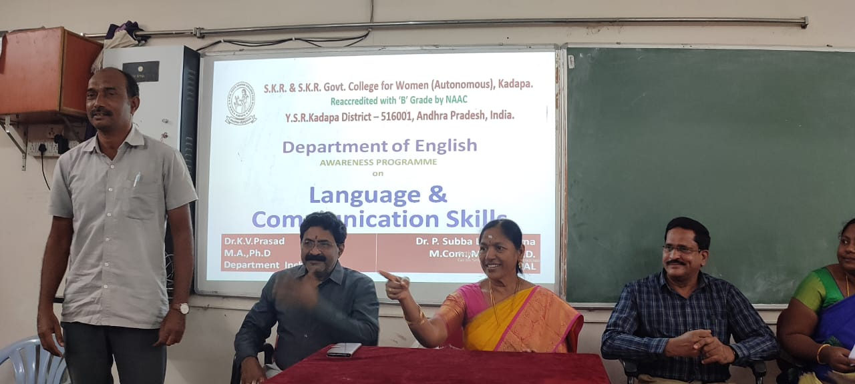

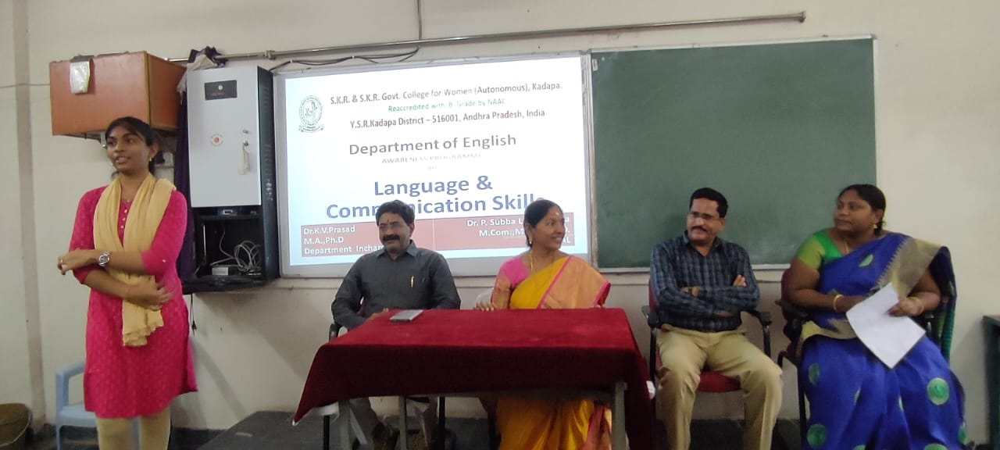

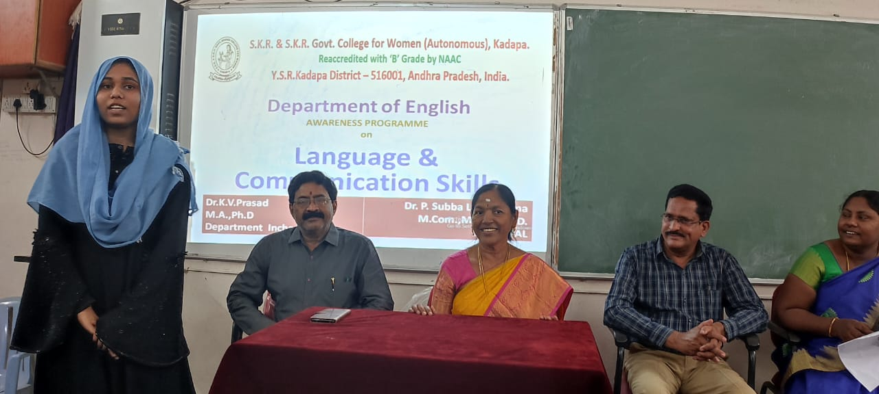

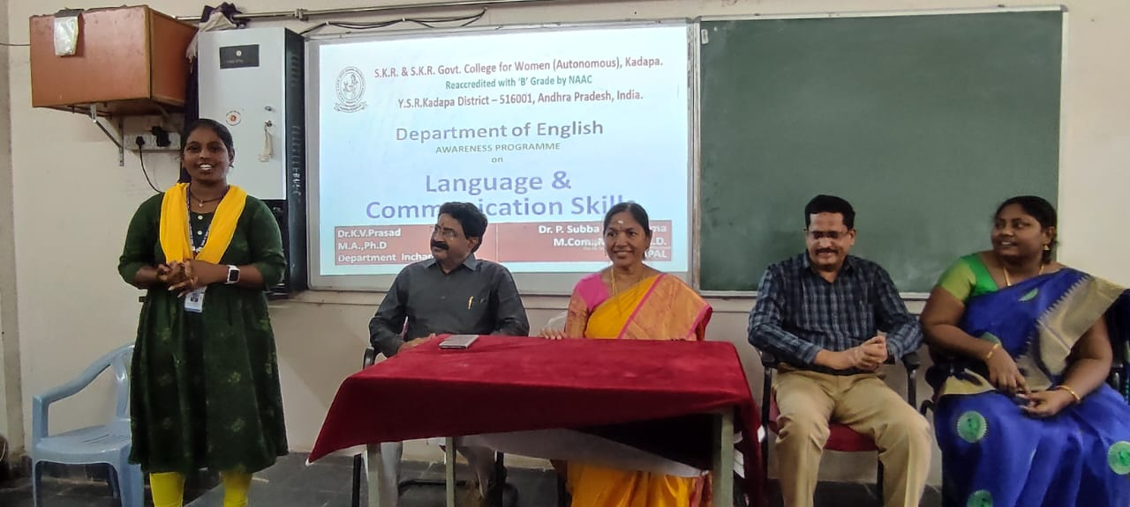

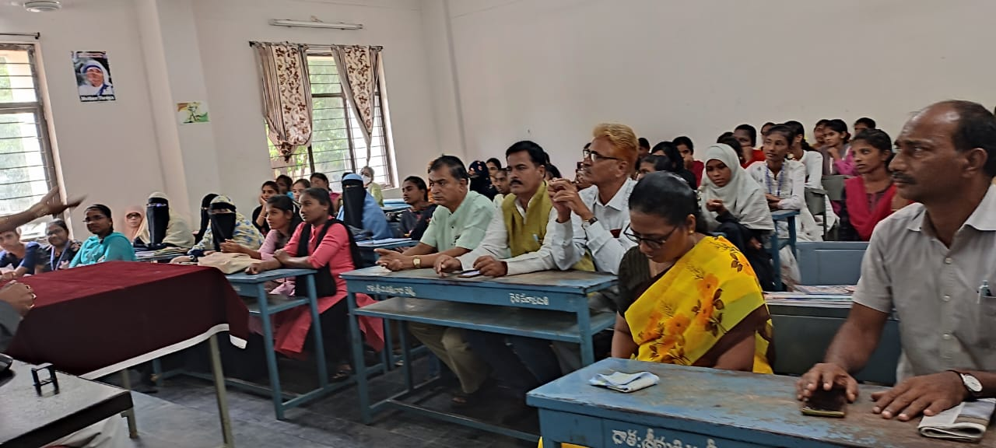

TECHNICAL SKILLS
The main purpose of this program was to create awareness regarding “Trends in Technology”.Balancing technology throughout the educational process and keeping with current trends which will affect everyone’s life, andthe impact of technology is very big and it gives us simple, faster and efficient life through the use of modern technology. Having awareness on current trends in technology is mandatory.
Our Hon’ble Principal Mam shared valuable ideas and motivated students to do well. Our Computer Science Department In-Charge Smt. A.Haritha spoke about the importance of changing technologies and adhering to them. The way we are seeing progress in technology, gave importance to learn and to exercise them. Smt. K. Vasudha Rani, Lect. in Computer Science gave an inspiring words to students to acquire knowledge in trending technologies. Kum. Pavani, II MPCS and Kum. Lakshmi Narasamma, II MSCS students participated in the program and shared their feedback as, the program is really well and they gained knowledge on current trends in technology. Students have shown immense interest and zeal in the event and are satisfied with the program.
By the end of the event, the purpose of imparting awareness on trends in technology was fulfilled; the way students participated in the event was quite good.

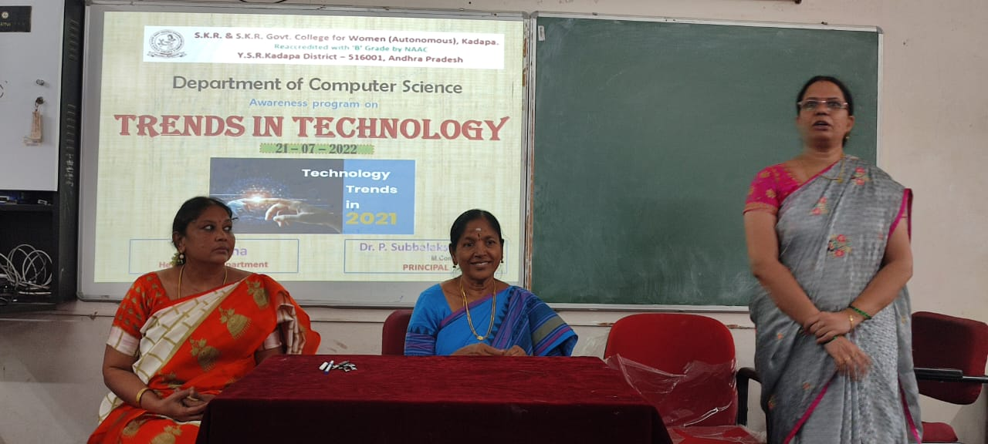

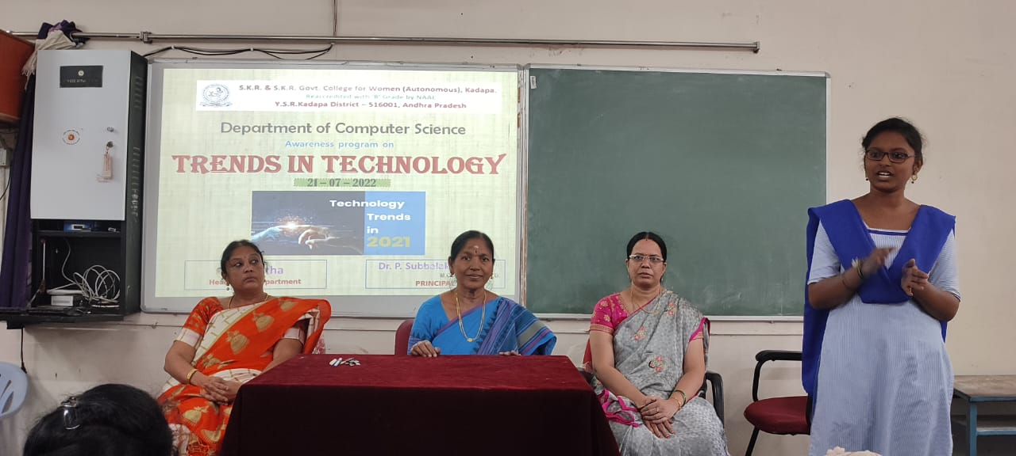

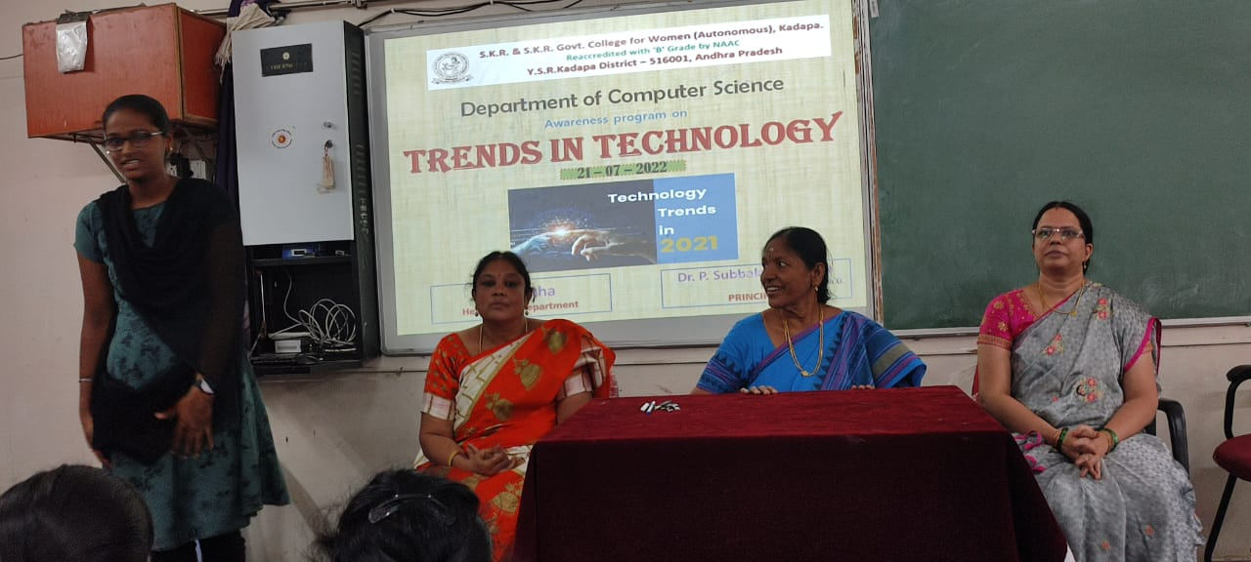

ANALYTICAL SKILLS

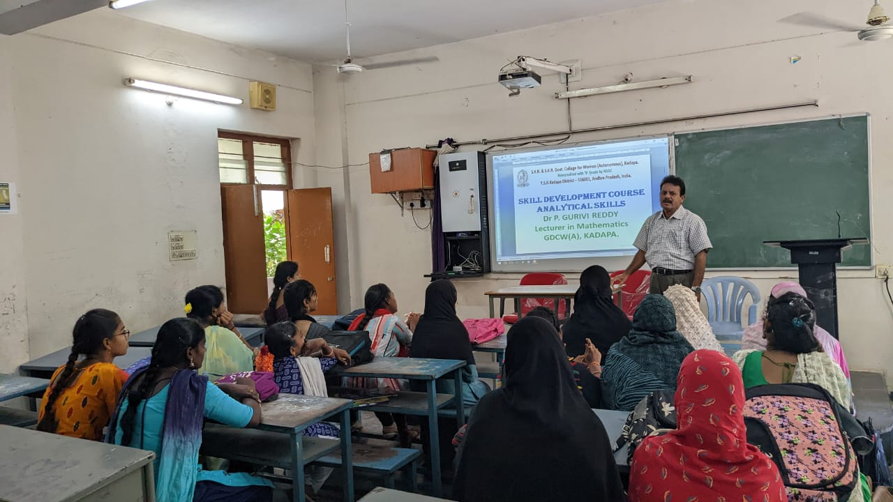

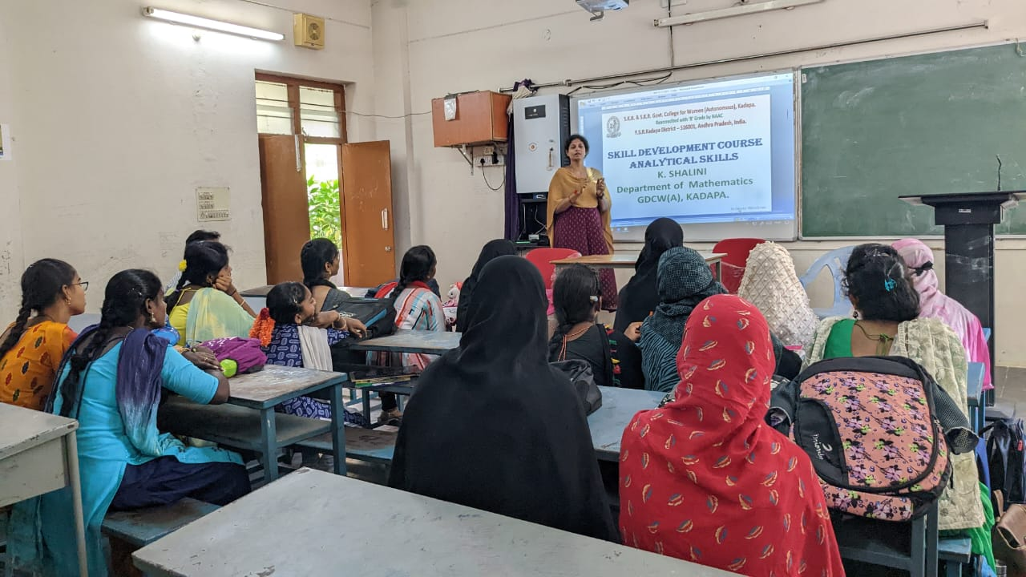

Life Skills (Yoga, Meditation & Physical Fitness)
